System Requirements
Windows 2003 or Windows 2008 with IIS installed. Windows XP/Vista/7 with IIS installed will work for demonstration purposes but not for production due to the 10 concurrent connections limit these operating system impose.
For Windows 2008 you need to make sure that you have the IIS 6 Management Compatibility Role Service for Web Server (IIS) Role installed, as well as - of course - the Web Server (IIS) Role itself.
SQL Server 2005 (or SQL Server 2008).
.NET Framework version 3.5 SP1.
Any computer capable of running the above software will also be capable of running CPR Broker.

Before installing CPR Broker
First make sure that the computer on which you want to install CPR Broker fulfills the System Requirements.
If you are installing CPR Broker on Windows 2008 you must first install the .NET 3.5.1 Feature via Server Manager. Then you should install the Web Server (IIS) Role together with the IIS 6 Management Compatibility Role Service.
CPR Broker can be installed as a root site (on Windows 2003 and 2008 only) or as a so called virtual directory to an existing root site.
If you want to install CPR Broker as a root site (which is what is recommended) you must prepare a DNS-record to point to the web server before beginning the installation. The installation program does not create this DNS-record for you.
If you want the web site to use Windows Authentication to connect to the SQL Server (this is not recommended, though) you also need to configure a special user domain account, which is used by CPR Broker’s notification service. When done with the installation this account should be given access to the database created by the installation program.
Now you are ready to install CPR Broker. See the chapter Installing CPR Broker for details.
After the installation finishes, some configuration steps are necessary. See the chapter Configuring CPR Broker for details.

Installing CPR Broker
Copy the installer zip package to the computer with IIS installed. Unzip the package. Double-click setup.exe to launch and click Next.
Please note: On a computer with User Account Control (Vista/2008/ 7) please right click and select ‘Run As Administrator’
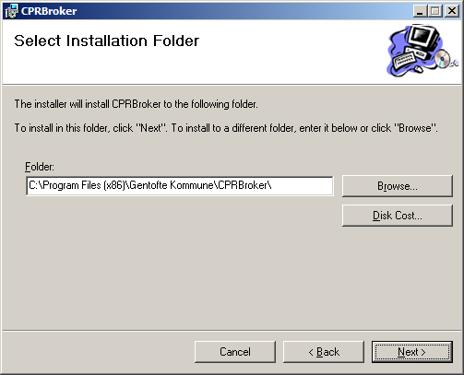
Choose where to install the files for CPR Broker. The default selection will most likely be a perfect fit. Click Next twice.
The installer now needs information on the CPR Broker web site should be installed
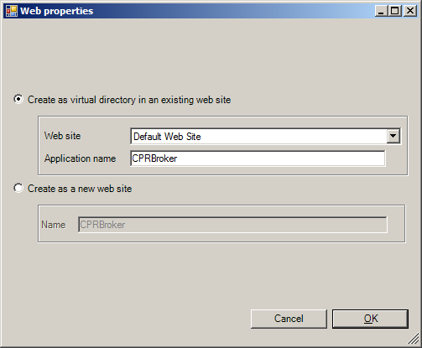
If you are installing on e.g. Windows XP you only have the option of installing as a virtual directory to the Default Web Site. The CPRBroker application name will be okay for most purposes.
If your IIS can have multiple sites (on e.g. Windows 2003 and 2008), choose which one in which to install CPR Broker. If you do not know what ”multiple sites” is, just let it go with the default selection.
You may also create a new website. Please note that this usually also demands that you make changes/additions to whatever DNS-solution your network uses.
Click OK.
The installer will now copy the files that make up the CPR Broker web site and services.
Next the installer needs information necessary to create the database in which it stores copies of CPR -information.
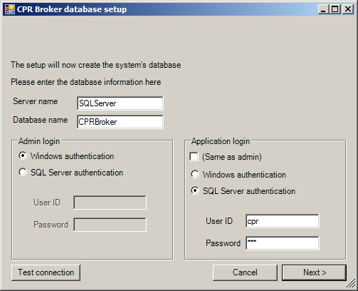
The Server name is the name or IP-address of the computer on which the SQL Server resides. It could be localhost if the SQL Server resides on the same computer as the web site.
Database name is the name of the database. CPRBroker would be a well chosen default name. If the database already exists, you will be given a warning message. If you accept it, the database will be used as it is. Please note that you will have to re configure the data providers because of encryption issues. Refer to the section “Data Providers” for details on how to do that.
Admin login is used for logging into the SQL Server and creating the database with the necessary tables etc. Whether you should use Windows authentication or SQL Server authentication depends very much on your setup. If the SQL Server is on the same computer as the web site you should most likely use Windows authentication.
Click Test connection to test whether the Admin login works.
Application login is used by the web site and services to connect with the database. The credentials needed for this purpose do not need to have as many privileges as the Admin login. Again it depends on your setup what kind of authentication you should use. If you use SQL Server authentication the installer will create the given User ID if it does not already exist.
When you are satisfied with your settings, click OK. The installer now creates the database and sets the connection string for the web site.
Click Next to create the database.

Extra step for event broker
The event broker needs to connect to CPR broker. This happens through 2 things
- A direct database connection used for logging
- A web service in CPR broker that is used to get the data needed by event broker to raise events.
This is configured in the following screen
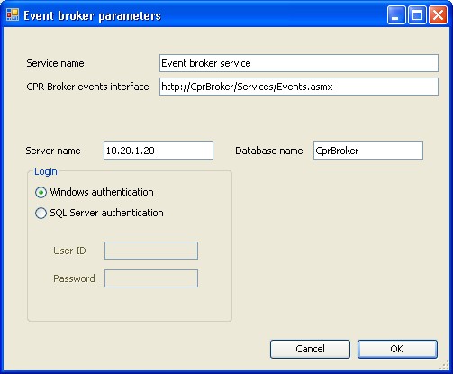
Event Broker comes with a so called Backend Service, which handles notification messages to subscribers. This service needs access to the same SQL Server as above. If you select to use Windows Authentication here, but you have selected SQL server authentication when you have installed Cpr Broker, then you have to manually allow the user ‘NT AUTHORITY\NETWORK SERVICE’ to access the database.
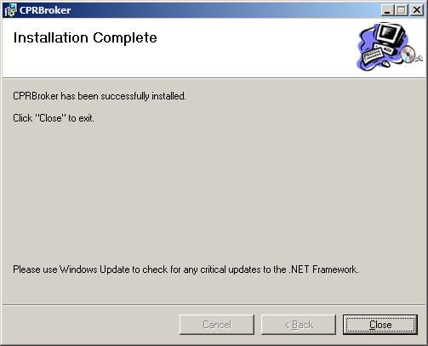
Click Close to exit the installer.

Configuring CPR Broker
Open up a browser and point it to http://localhost/CPRBroker/Pages/default.aspx (or whereever you chose to install it) to see whether your installation was successful
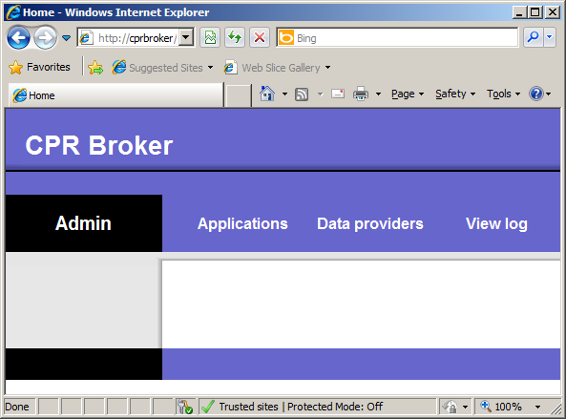
This is a basic interface but it does get the job done.

Applications
Now click Applications:
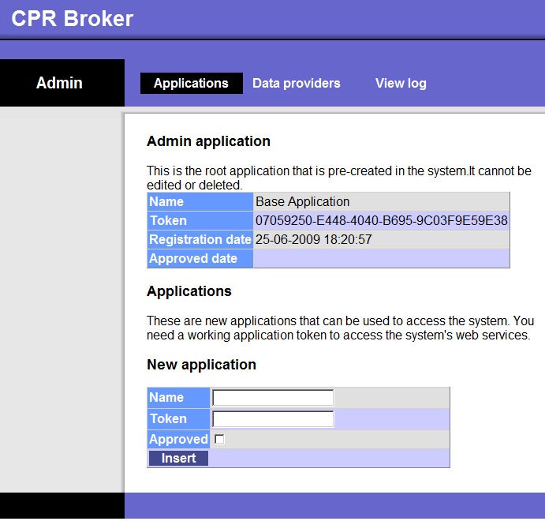
The Admin application is a built-in name for an application that is allowed to work with the administrative parts of the CPR Broker. Look at the Token. This long hexadecimal (digits 0-9 and letters A-F) number is used by the Admin application so the CPR Broker service knows who it is.
The system comes also with 2 other (separate) applications, one for the event broker and the other for the demo application.
Let’s see how it looks when CPR Broker Demo has been registered:
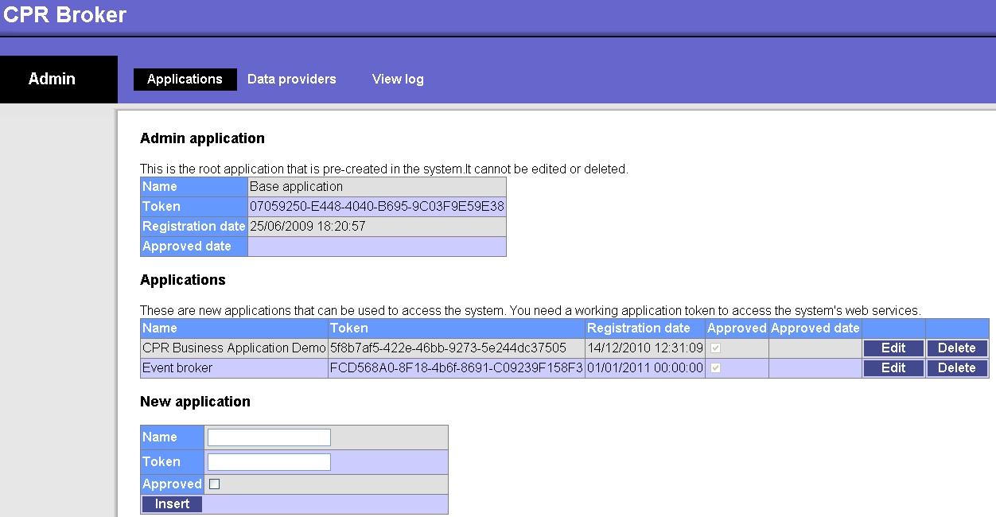
As you can see there is now one registration under Applications: CPR Business Application Demo, which is what the CPR Broker Demo calls itself. You can also see that it has been Approved.
Normally when external applications register themselves with CPR Broker Service they get an application token, but they are not allowed to do anything with the service before the application has been Approved.
To approve an application, simply click Edit for the application in question and check the Approved check box. Then click Update (only shown after Edit).
You can also enter a new application manually. Simply give it a Name, a Token and whether it should be initially approved (it probably should). Then click Insert. The application is now listed under Applications.

Data Providers
Now click Data Providers:
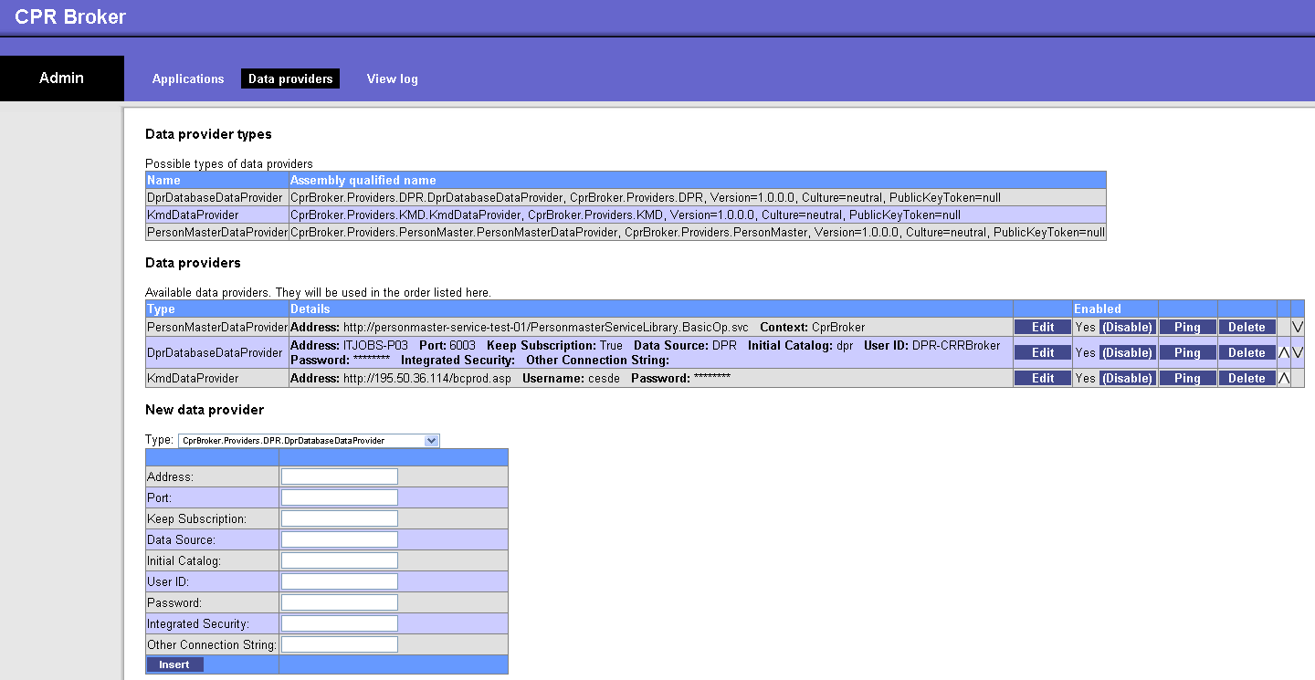
A Data Provider is a connector that provides the broker with information. Currently there are two groups of data providers
- Person master data providers: Used to assign UUID’s to Cpr Numbers
- CPR data providers: KMD and CPR.
To setup any of these connections you need an account and connection information from the provider. Then choose the appropriate provider type, enter the information and click Insert. You now have a Data Provider.
Please note! CPR Broker is unusable without data providers! You need at least one provider from each of the above groups.

Setting up logging
CPR Broker can log to file, Windows Event Log, to the Database and to email.
There are two places to setup logging: In the loggingConfiguration.config file for CPR Broker web service. The default position for this is C:\Program Files\ITST\ CPR Broker\Web\Config – and in the CprBroker.EventBroker.Backend.exe.config file for the Backend service. The default position for this is C:\Program Files\ITST\Event Broker\Web\bin\.
The procedure is the same for both files. Locate the < loggingConfiguration> tag in the specific config file. Under the <listeners> tag you will find four <add tags. The "CprDatabase" as well as the "EventLog" should be left untouched in all cases.
In "FlatFile" you should look for the fileName attribute. This should be set to the full path and name of the where to put the log file.
In name="Email" there are more settings. The ones most likely to be adjusted are: toAddress, fromAddress, smtpServer and perhaps smtpPort.
Please note: In the last 3 cases, you need to make sure that the ‘NT AUTHORITY\NETWORK SERVICE’ account has sufficient access rights to the destination.
You have now adjusted the settings for each type of logging, but you have yet to set what types of logging are active. You now look for the <specialSources>/ <allEvents> tag. In this you will another <listeners> tag. Per default "CprDatabase" is active, which can be seen from the fact that it is not commented out like e.g. <!--add name="EventLog" /--> is.
To enable a specific listener simply remove the <!-- and --> characters from the line. And to disable a listener simply put them back in.

Uninstalling CPR Broker
If you want to uninstall CPR Broker please open the Add/Remove Programs in the Control Panel. Click Remove.
You may be asked:
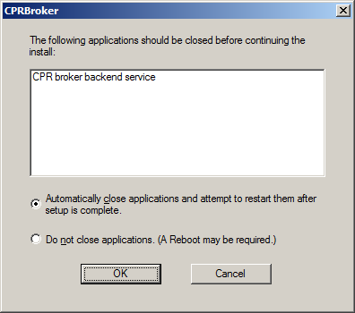
You can safely answer OK to this.
During the removal of CPR Broker you will be asked whether to delete the database:
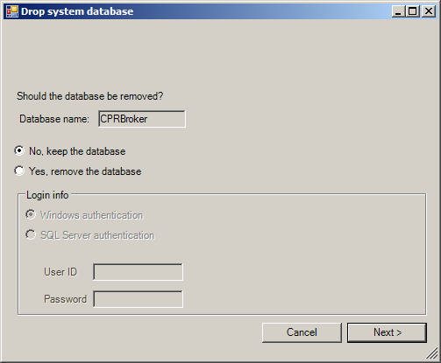
You may need to provide a specific username and password which have rights to delete the database from the SQL Server used.
Click OK and CPR Broker will be removed from the computer.

